**Name:** Mustafa Baran Ercan   
**ID:** 2881055520 **Section**: CMPE_360_01

**Name:** Neslihan Pelin Metin   
**ID:** 71047171244 **Section**: CMPE_360_02

PROJECT 9 REPORT

PART 1

* What each person in your group did
* Add screenshots of objects (8 objects)

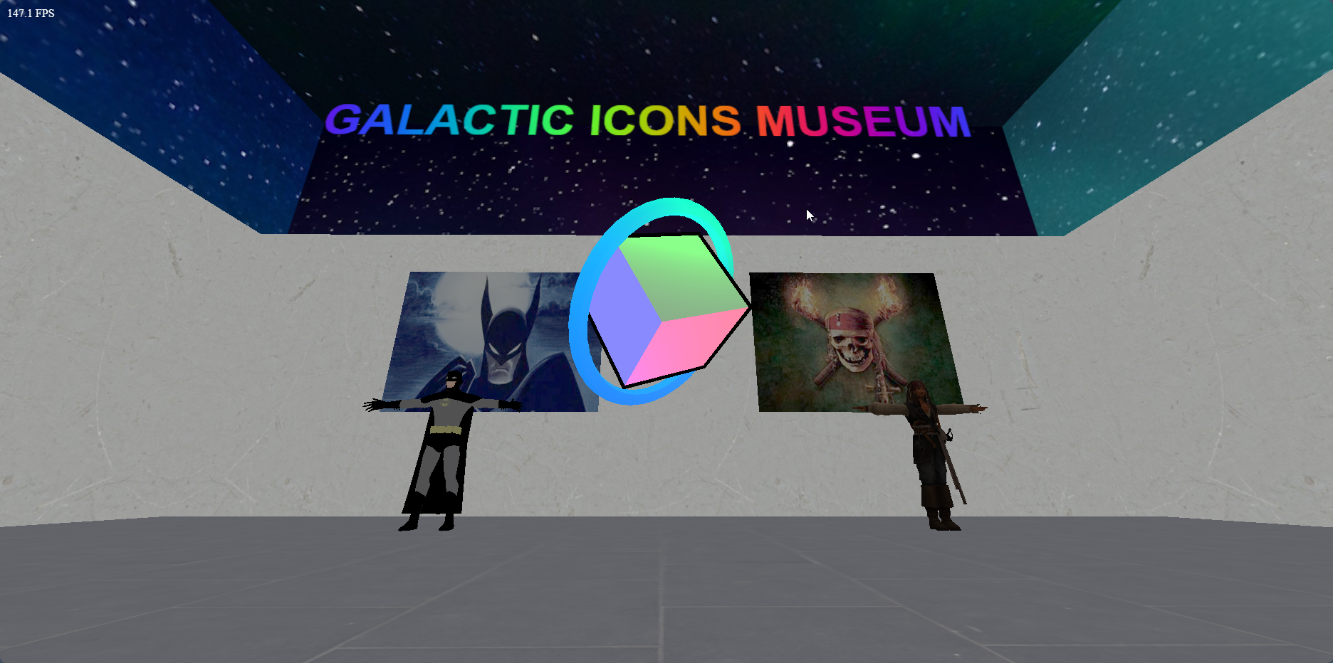

(Objects in the scene: Cube, Ring, Text, Batman, Batman Poster, Jack Sparrow, Pirates of Caribbean Poster.)

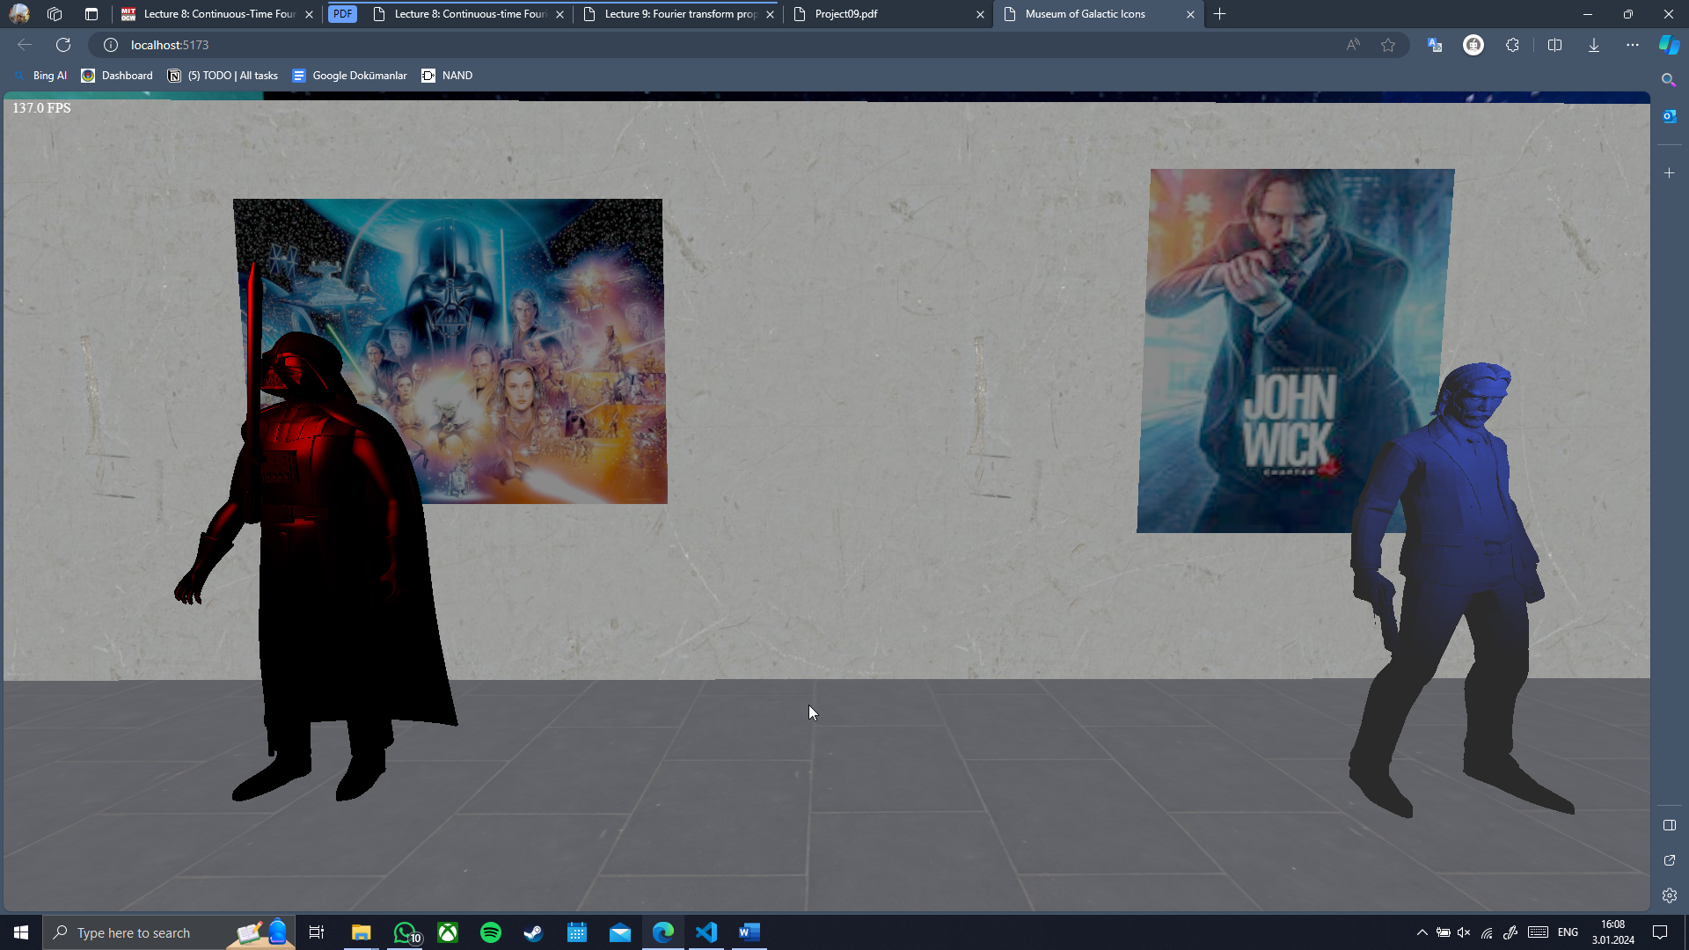

(Objects in the scene: Darth Vader, Star Wars Poster, John Wick, and his poster.)

* Write geometry types (at least 3) geometry you use.

Cube and Ring Custom OBJ models

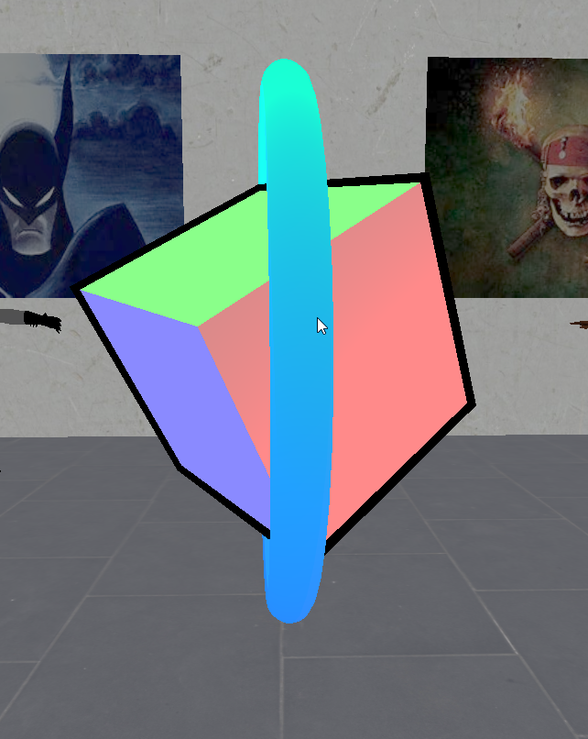 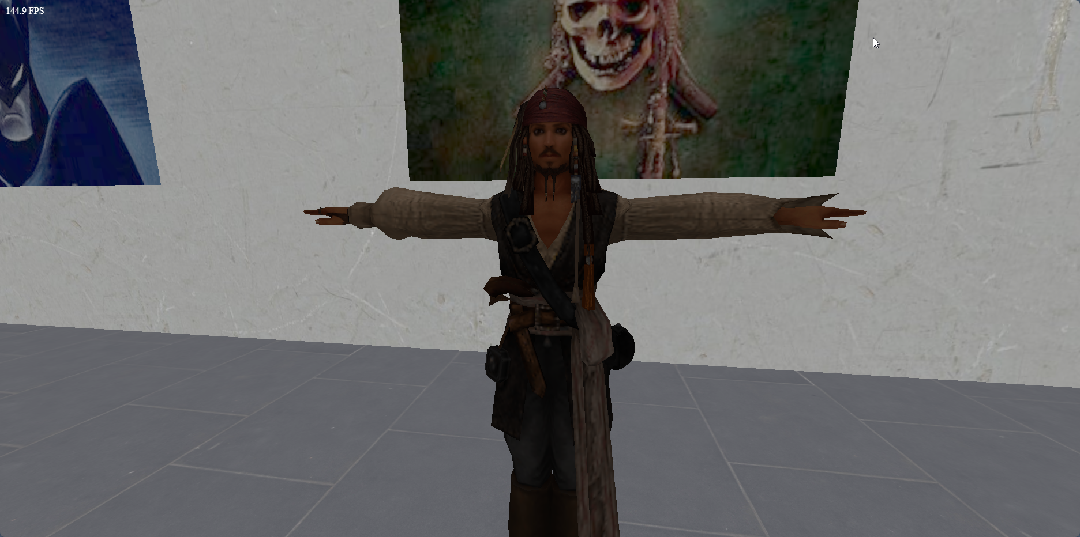

Plane (Walls, Floor and Posters)

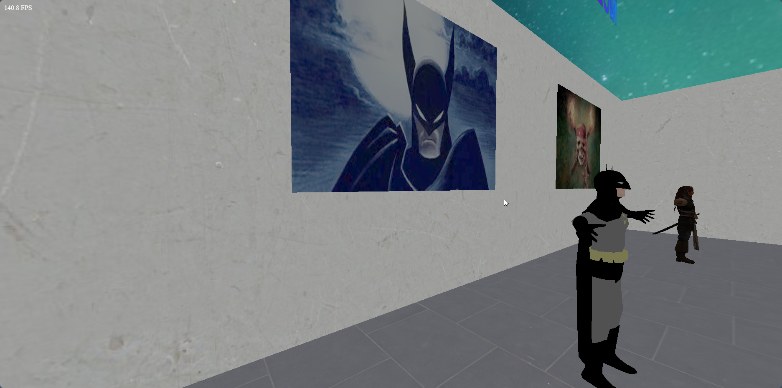

PART 2

* Add multiple lights, skybox and texture mapping and explain your process.
* Which features are animated, explain your process.
* Write shader effects you used explain your process.
* Files and any additional files (.html and .js files) (with detailed comments)
* Creativity of scene
* Add two screenshots with different camera views of your scene when you finish your work.

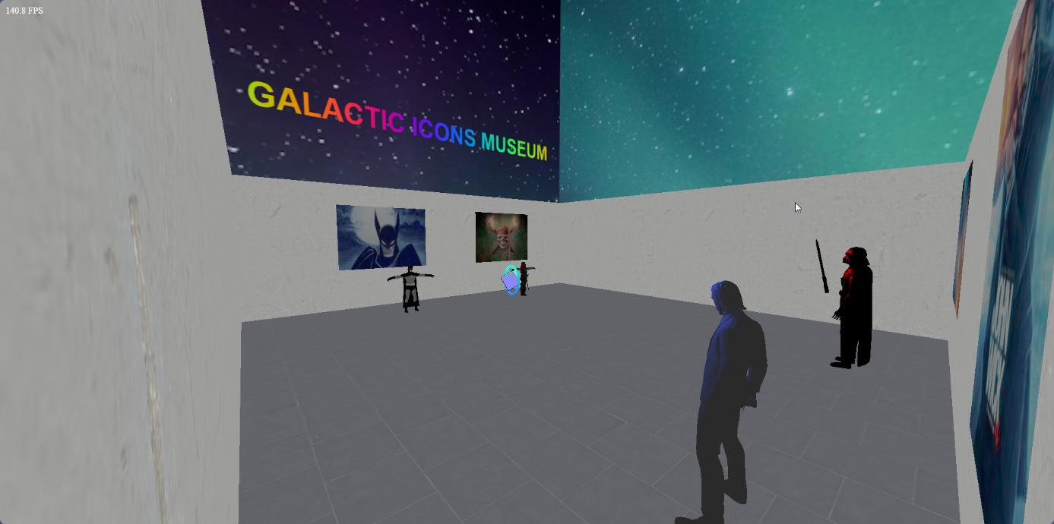

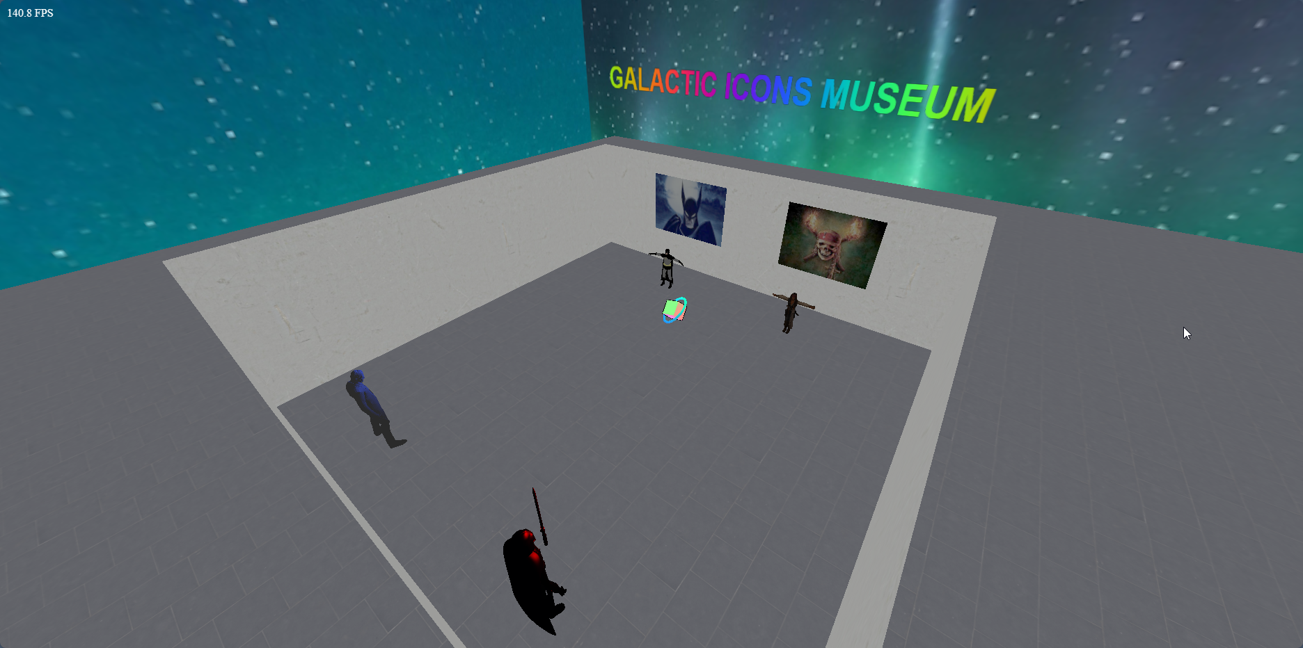

* Please record a video the all options and copy the drive link to your report

<https://drive.google.com/file/d/1ksTjnqMxKocQMhBInPq72kxTylaaL2xP/view?usp=sharing>